**POWER BI ASSIGNMENT-4**

**Use Case -** Working with Date & Delimiter

**Source -** GOT

Q1. The Raw data- your task is to transform it into something more presentable

**Step-1.** We will load data from get data option and we click on transform

**Requirement**

1. Split the author column in two and replace the resulting null with blanks.

**Step-2**. To Split the Written by column we will use split column option using transform option and then we will use the option to split by special character after that replace the null value by blank

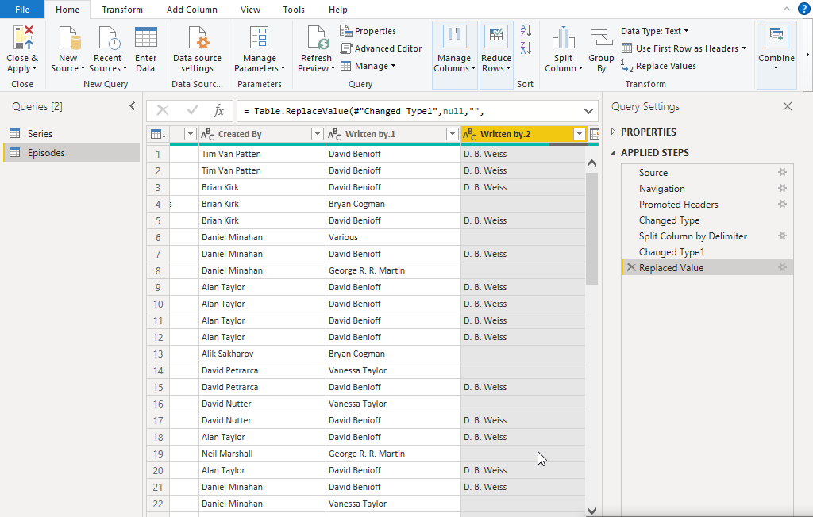

1. The date need to be format as I am not happy they are appearing.

**Step-3.** Select column Release date so that the column tools will appear and change the date as required.

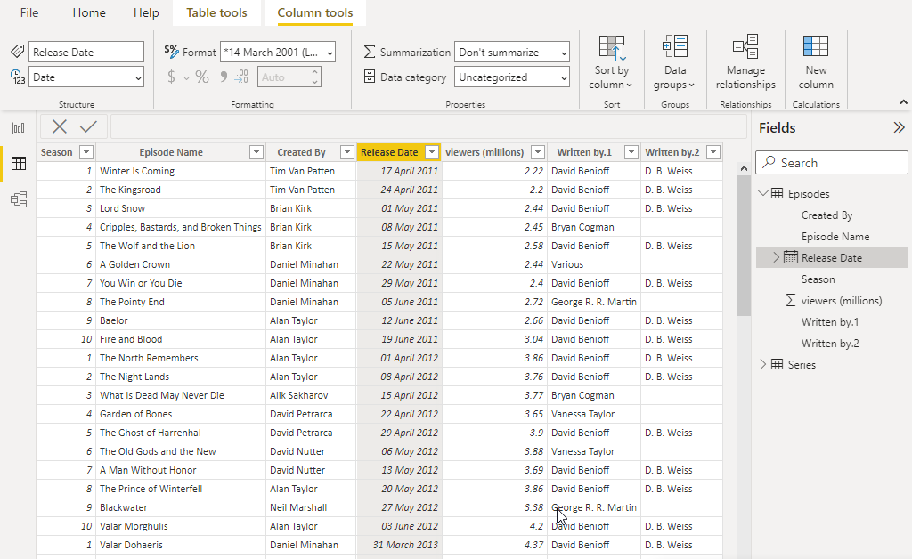

1. You should also filter the data to show only episodes directed by Daniel.

**Step-4.** Filtering the episodes directed by Daniel.

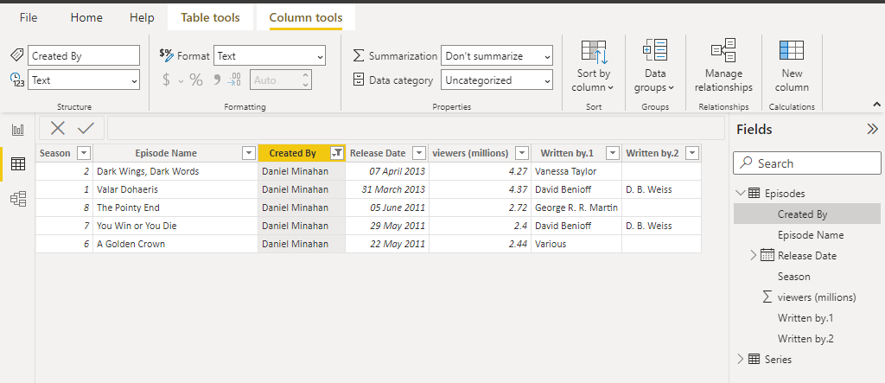

1. Should show how many people watched each episodes written by the various authors.
2. Episode Name
3. No of viewers
4. Mostly watched director

**Step-5.** Show in visualization the how many people watched episodes written by authors

